For this exercise of Visualizing Convolution Layers, I have chosen to use RestNet152V2 model with the following details.
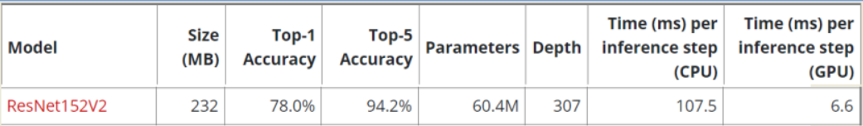
This is a snippet of the list of the layers of the model ResNet152V2
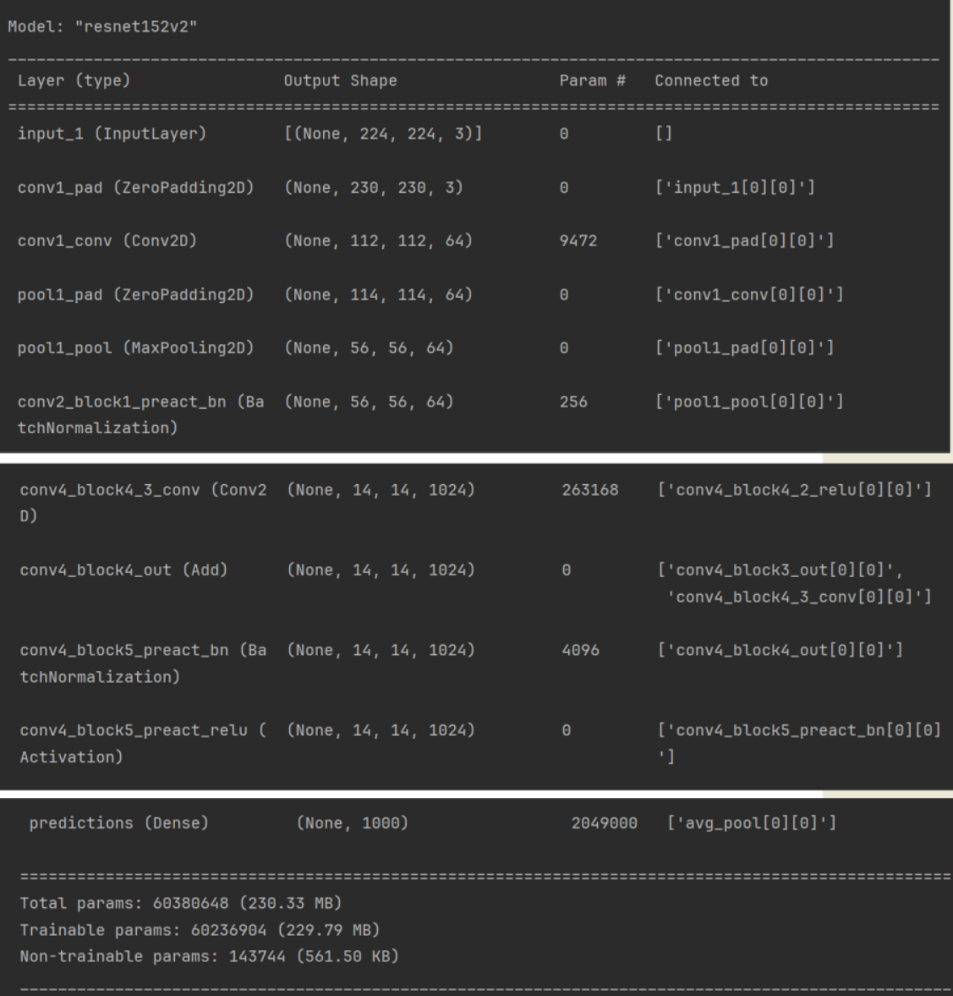
Our chosen target layer is ‘conv4_block4_out’, we will visualize the filters from that layer.

This is what an input that maximizes the response of filter 0 in the target layer would look like:
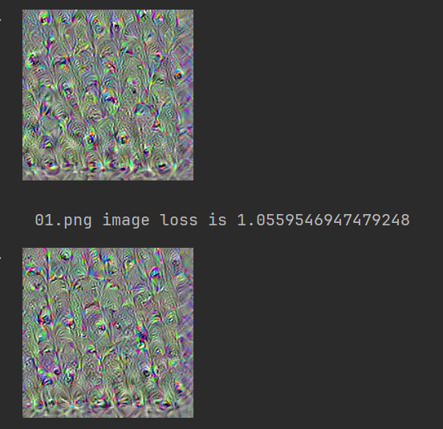
Visualize the first 64 filters in the target layer.
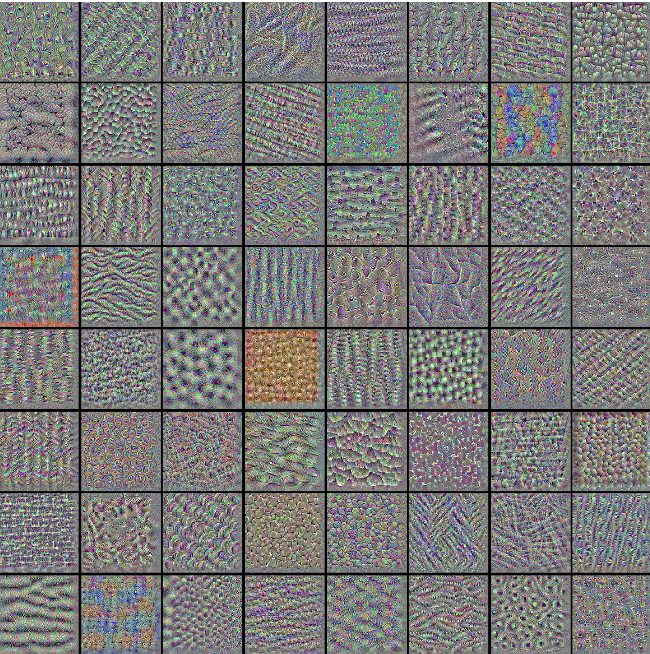

Here we are going to use an elephant image from google images, the model takes an image and outputs a feature map.

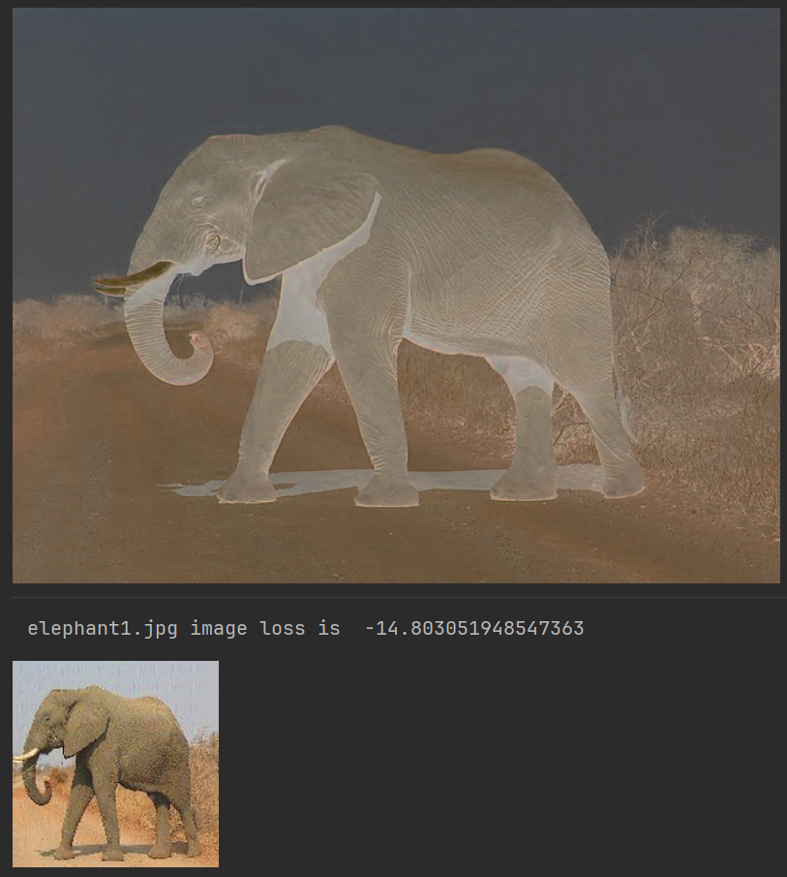

Here we are visualising the feature map
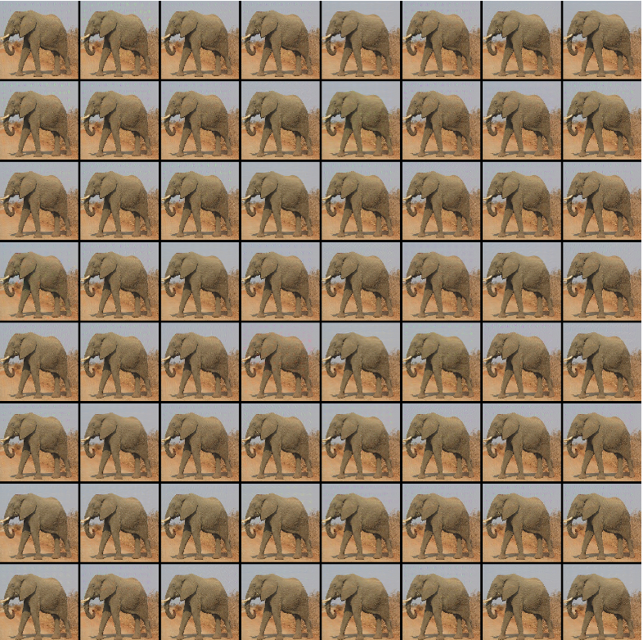
This is a snippet of using the image classification models to predict the image.
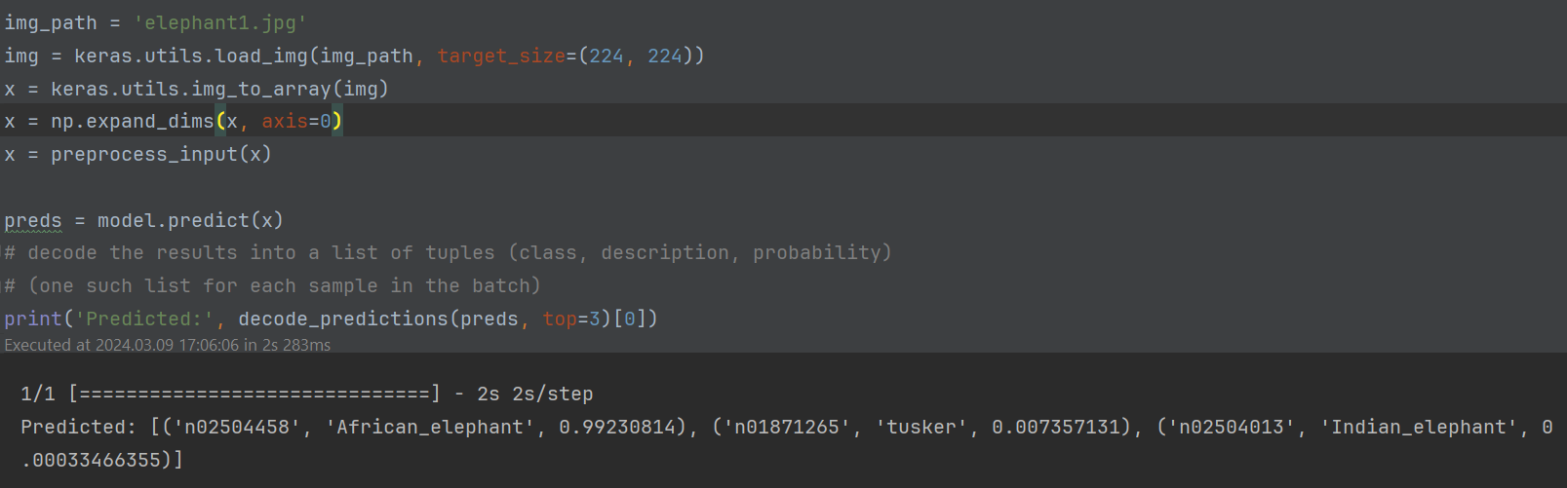
According to the model ResNet152V2 the elephant in the image is an African breed with confidence level of 99%.

